Introduction to Computer Networks

**What is Computer Networks?**

A computer network is a set of nodes connected by communication links.

A node can be a computer, printer or any other device capable of sending/receiving data generated by other nodes in the network.

**Example of Nodes:**

1. Computer
2. Server
3. Printer
4. Security camera
5. Many more (Switches, Bridges, Routers etc.)

A communication link can be a wired link or wireless link.

The link carries the information.

**Links (Medium):**

1. Wired: CAble
2. Wireless: Air

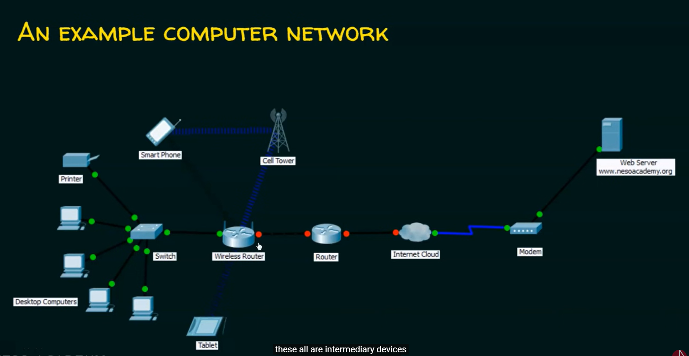

Computer network mainly used for RESOURCE SHARING.

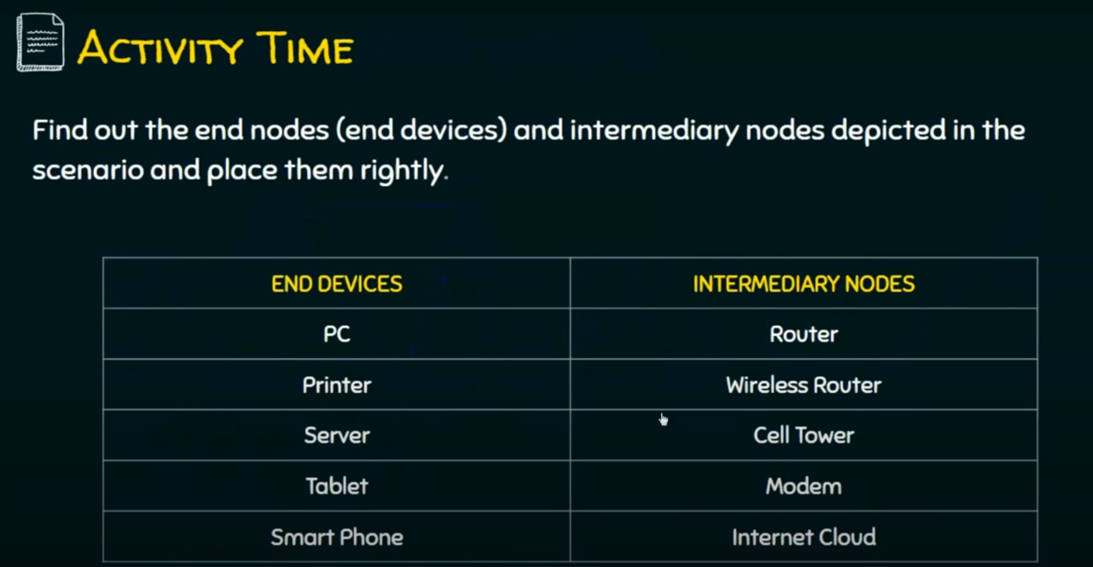

Devices which are source or destination are end devices.

The devices which forward the data from one side to other side, they are called intermediary devices.